Tutorial – Workplace Health and Safety

Creating a Safety Report:

In this tutorial we are going to identify the hazards in your workplace, assess their level of risk, and list some control methods that can be implemented to reduce the level of risk associated with a hazard.

You will document this process to create a WH&S report that will be submitted as part of your assignment.

If you are studying on-campus, you should assess your classroom. If you are an online student you will identify and assess the hazards in your home office or study space.

1. Identify Hazards:

Identify hazards in your workspace. List each hazard in the table below.

Use the Risk Matrix on page 2 to measure the risk level of each hazard.

|  |  |  |  |
| --- | --- | --- | --- |
| Hazard | Consequence | Likelihood | Risk Level |
| Boxes on the floor | Trip hazard (minor) | Possible (3) | Medium |
| Glare from screen | Eye damage (Catastrophic) | Possible (3) | High |
| Bad chair/posture | Back pains and damage (Catastrophic) | Possible (3) | High |
| Damaged cables | Electrocution (Catastrophic) | Unlikely (2) | Medium |
| Tight power cable | Tripping (minor) | Possible (3) | Medium |
| Water on Desk | Electrocution (Catastrophic) | Possible (3) | High |
| Bright white light emitting from screen | Eye damage (Catastrophic) | Possible (3) | High |
| Headphones too loud | Hearing loss (Major) | Possible (3) | Medium |
|  |  |  |  |
|  |  |  |  |
|  |  |  |  |
|  |  |  |  |
|  |  |  |  |
|  |  |  |  |
|  |  |  |  |

|  |  |  |  |  |  |
| --- | --- | --- | --- | --- | --- |
| IMPACT | LIKELIHOOD | | | | |
| Rare (1) | Unlikely (2) | Possible (3) | Likely (4) | Almost Certain (5) |
| Catastrophic (A) | M | M | H | C | C |
| Major (B) | L | M | M | H | C |
| Moderate (C) | L | M | M | M | H |
| Minor (D) | L | L | M | M | M |
| Insignificant (E) | VL | VL | L | L | M |

|  |  |
| --- | --- |
| Risk level | Required action |
| Critical | Act immediately:  The proposed task or process activity must not proceed. Steps must be taken to lower the risk level to as low as reasonably practicable using the hierarchy of risk controls. |
| High | Act today:  The proposed activity can only proceed, provided that:  (i) the risk level has been reduced to as low as reasonably practicable using the hierarchy of risk controls;  (ii) the risk controls must include those identified in legislation, Standards, Codes of Practice etc.  (iii) the risk assessment has been reviewed and approved by the Supervisor and  (iv) The supervisor must review and document the effectiveness of the implemented risk controls. |
| Medium | Act this week:  The proposed task or process can proceed, provided that:  (i) the risk level has been reduced to as low as reasonably practicable using the hierarchy of risk controls;  (ii) the risk assessment has been reviewed and approved by the Supervisor. |
| Low | Act this month:  Managed by local documented routine procedures which must include application of the hierarchy of controls. |
| Very Low | Keep a watching brief:  Although the risk level is low the situation should be monitored periodically to determine if the situation changes. |

2. Recommend Control Mechanisms:

Now that you have identified the hazards in your work environment and allocated a level or risk to each hazard, propose solutions to minimize the risk of each hazard.

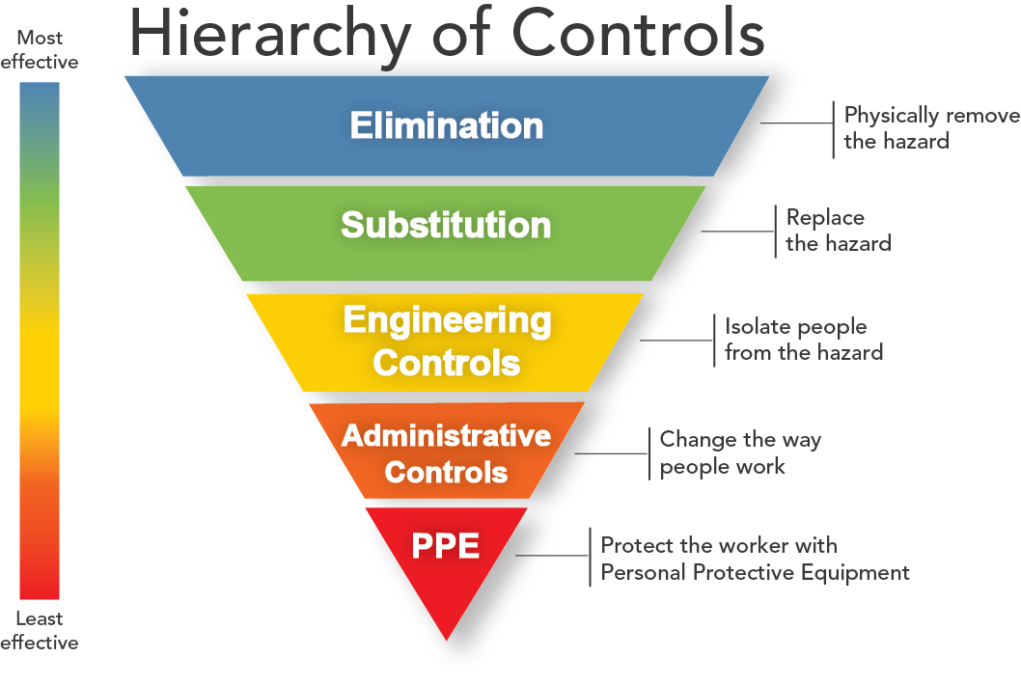

For each hazard try to use one of the more effective methods of control first. If that is not possible, a less effective method will suffice.

Complete the table below, listing one or more control methods for each hazard you identified above.

|  |  |
| --- | --- |
| Hazard | Control Method |
| Boxes on floor (trip hazard) | Stack boxes in corner of room or put in closet |
| Glare from screen | Close windows that may be causing glare, or tilt monitor |
| Bad chair/posture | Sit upright and adjust chair correctly |
| Damaged cables | Fix them / buy new ones |
| Tight power cable | Get an extension cord |
| Water on Desk | Remove water from desk |
| Bright white light emitting from screen | Dim screen, use computer dark mode if possible |
| Headphones too loud | Turn volume down |
|  |  |
|  |  |
|  |  |
|  |  |
|  |  |

Once you have filled in both tables, submit your safety report to your teacher for assessment.